

**INTRODUCTIONTO**



**GIT&GITHUB**

Presentedby: Ujjwal Singh IT-68



Prince Rajput IT-69 RajNagar IT-70

Guidedby: Dr.LalitPurohitSir and

Mr.UpendraSinghSir



**Overview**

What is Version Control System ?About Git & GitHub

Difference between Git & GitHub Setting up Git

ConfigureGit

Account Creation of GitHub Branching,Forking,Merging Basic commands of Git Upload Project on GitHub



# WhatisVersionControlSystem?

1. **Ittrackschangestofilesandcode.**
2. **Facilitatesefficientcollaborationformultipleusers.**
3. **Recordsmodificationsandmaintainsachangehistory.**
4. **Enablesbranchingandmergingforseparatedevelopmentpaths.**
5. **Allowsrevertingto previousprojectversions.**
6. **Ensuresstructureddevelopmentandreliableprojecthistory.**

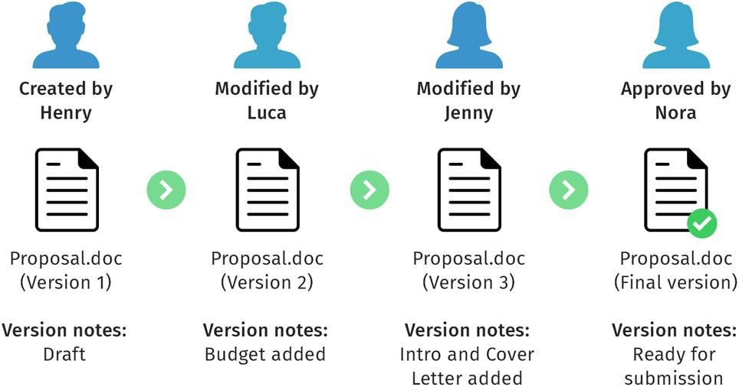



# Git:

* 1. **Git:Trackschangesincomputerfiles.**
  2. **Coordinatesworkamongmultipleusers.**
  3. **Distributedversioncontrolsystem.**
  4. **Allowssimultaneouscollaborationonfiles.**
  5. **Widelyusedinsoftwaredevelopmentforcodecollaboration.**

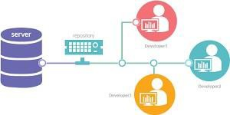



# CharacteristicsofGit:

1. **DistributedVersionControl:**

Gitisadistributed versioncontrolsystem,allowingmultipleuserstoworkona project simultaneously.

1. **Snapshot-based:**

Gitrecordstheentireprojectatdifferentpointsintimeassnapshots,makingit efficient and providing a complete version history.

1. **BranchingandMerging:**

Gitenableseasybranchingtoworkondifferentfeaturesorchangesindependently and allows seamless merging of branches.

1. **LocalOperations:**

Most Gitoperations areperformed locally,making it fast andefficient, without requiring a constant connection to a central server.



# GitHub:

1. GitHubisaweb-basedplatformforcollaborativedevelopment using Git.
2. 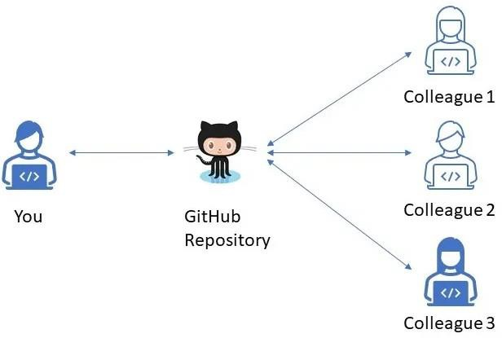Itservesasacentralizedlocationforstoring,managing, and sharing code.
3. Userscreaterepositoriestohostprojectsandtrack changes through Git version control.
4. Collaboration is facilitated, allowing multiple contributorsto work onthesame codebase.
5. GitHubprovidesfeatureslikeissuetracking,pullrequests, and discussions.
6. It is widely used for team-based software and open-source projects.



development

## Git

**Difference**

## GitHub

 Distributed version control system.  Operateson adeveloper'smachine.  Manages code versions locally.

 No internet dependency.  No collaboration features  Command-line tool.

 Web-basedplatform.

 Hostsrepositoriesinthecloud.

 Providesproject management features.  Requires internet access for usage.

 Facilitatesremotecollaboration.

 Providesagraphicalinterface.



# CreatingaccountonGitHub:

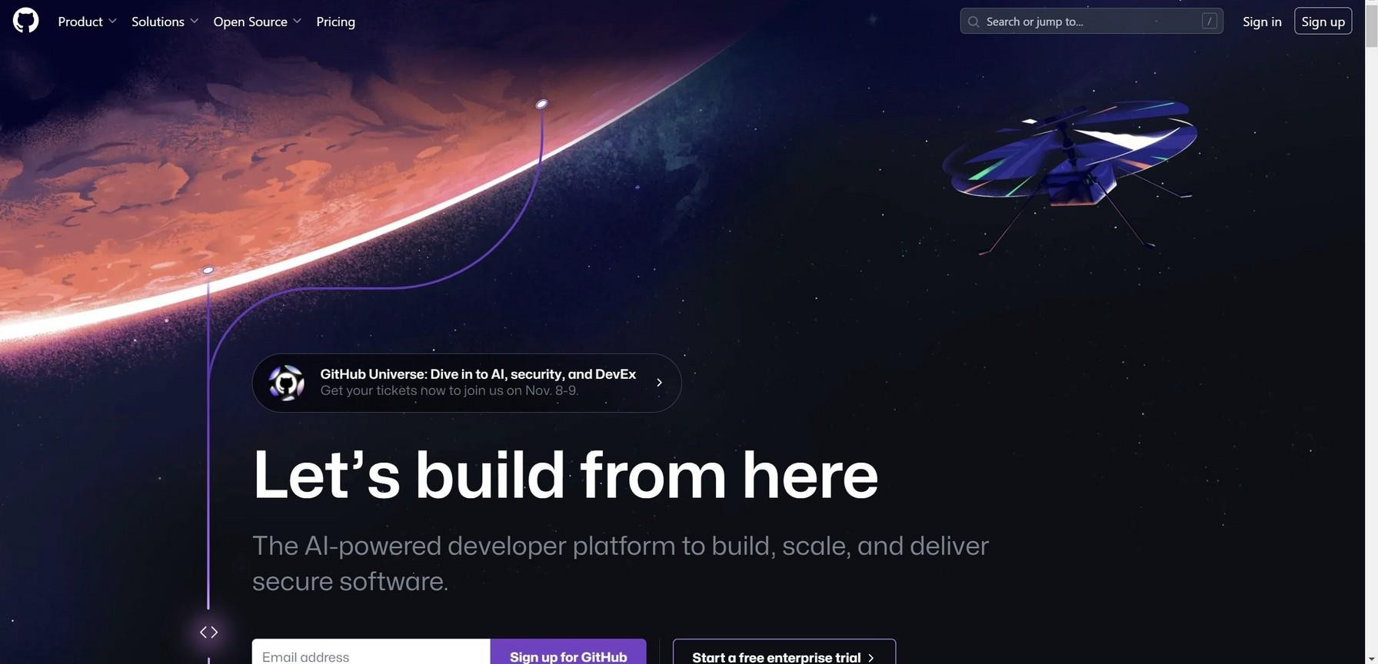

* 1. Openyour web browserand goto the GitHub website at [https://github.com.](https://github.com/)



* 1. On theGitHub homepage,you'llseea"Sign up"form.Enteryourdesired email address and password.

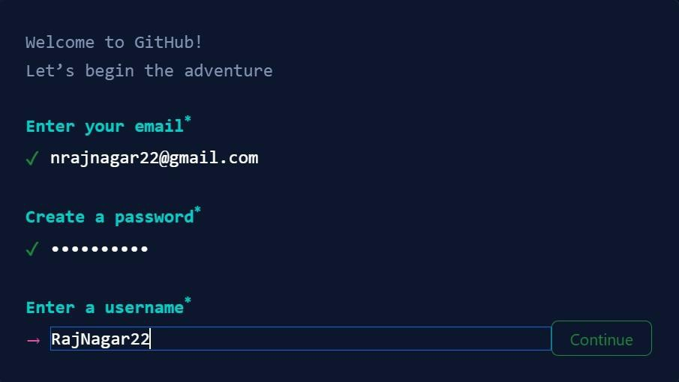





* 1. GitHubwillsendaverificationemailtotheemailaddressyou provided.Go to youremailinbox,open theemailfromGitHub, and followtheinstructions to verifyyour email.

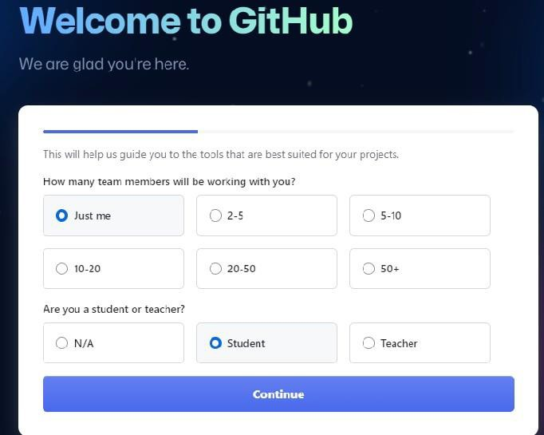

* 1. You'llbepromptedtocompletethesign-up process. Optionally, you can:

 Customizeyourexperiencebyselectingyourinterests.

 Chooseto receiveupdatesandnewslettersfromGitHub.

* 1. Acountcreation iscompleted,personalizeyouraccountasperyourneeds.

# CreatingNewRepositoryinGitHub:

1. LogintoyourGitHubandClickonthetoprightcornericon.
2. 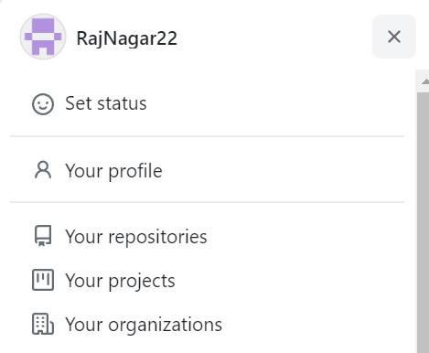Fromtheappeareddropdownlistselect“YourRepositories".

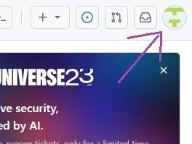

1. Nowselect“New”button



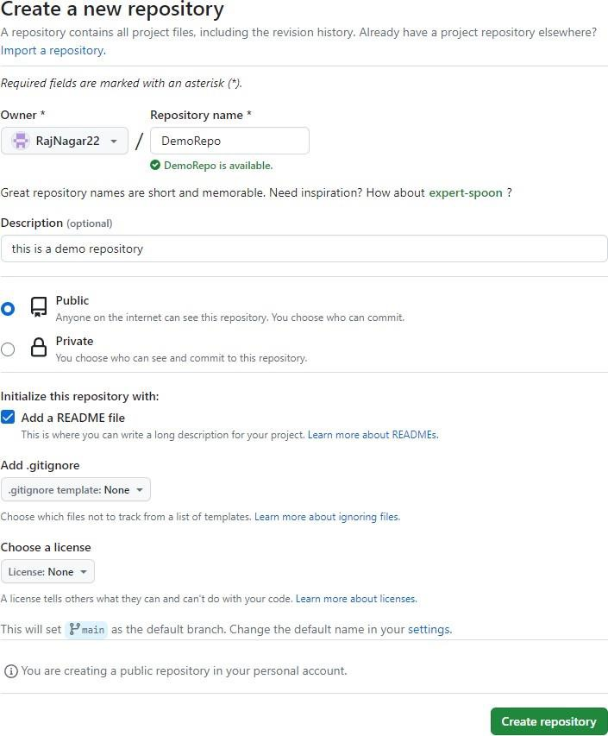4.A new formwillappear,typealltherequireddetailsofthenew repository inthe form andclick on “Create Repository” Button. Then the new repository will be created on GitHub.



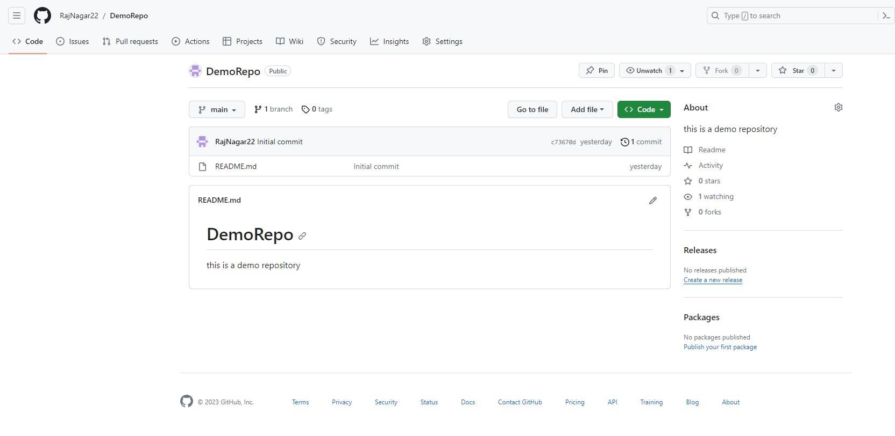

1. NewlycreatedRepositorywillappearlikethis:

# SettingUpGit:

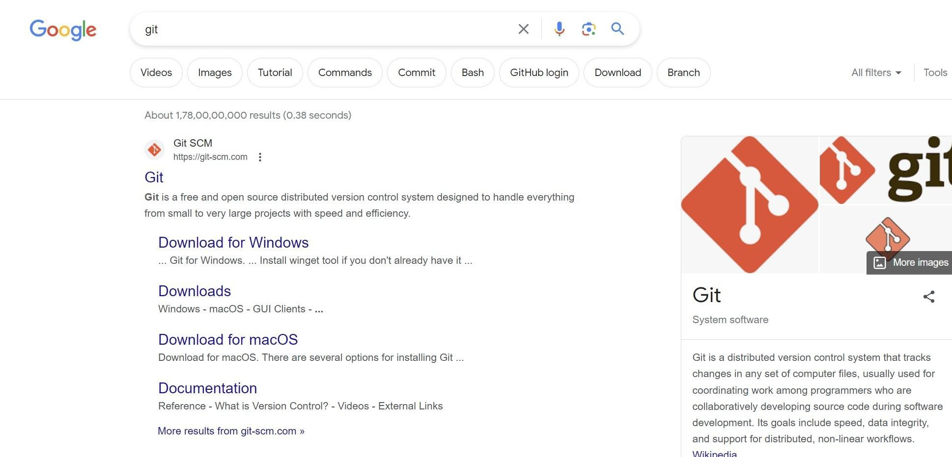

* 1. Typegitinyourweb browser’ssearchbar.

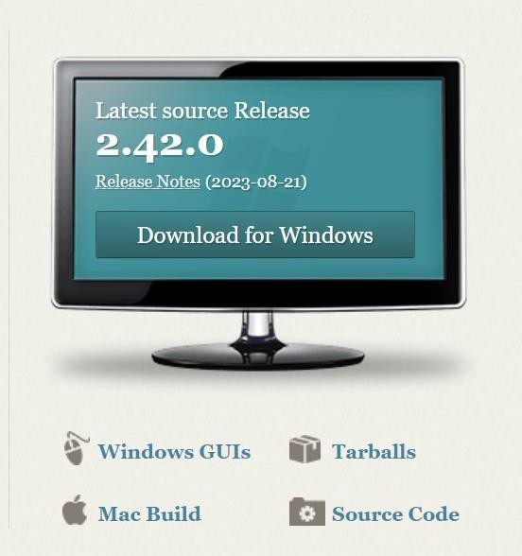

* 1. Ifyou’reawindowsuserclickdownloadforwindows,else click on mac build.

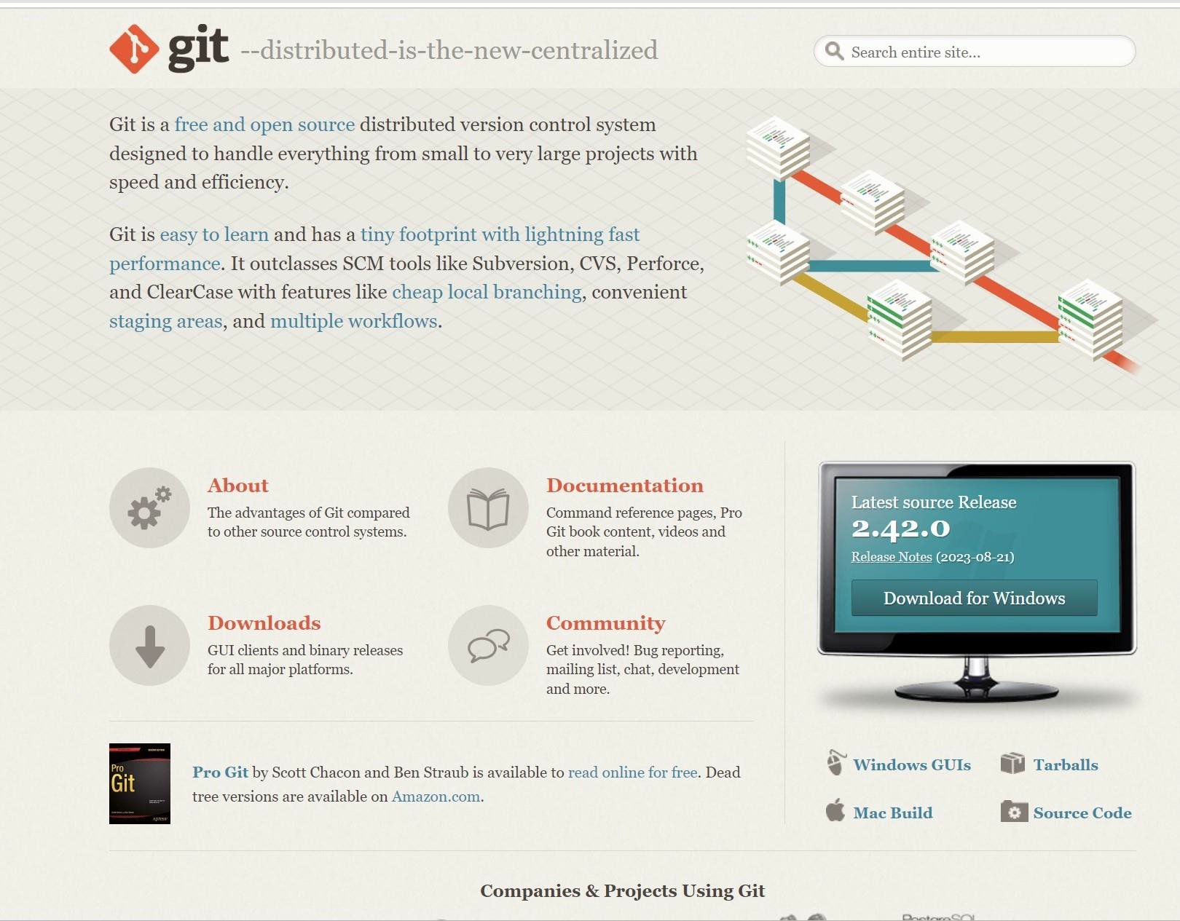



* 1. Macusersshouldfollowthegivenprocedure:

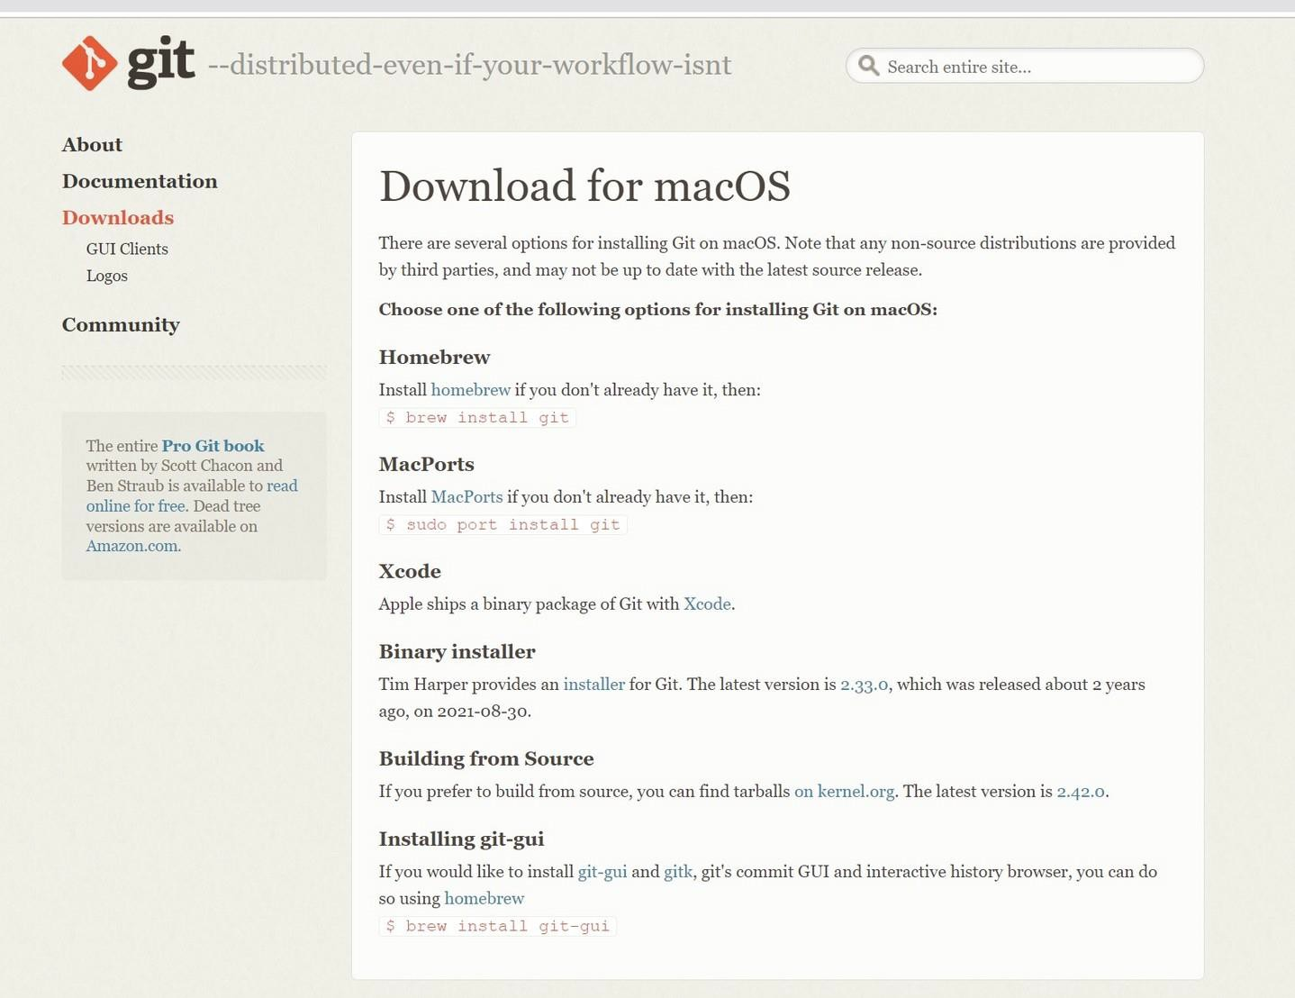



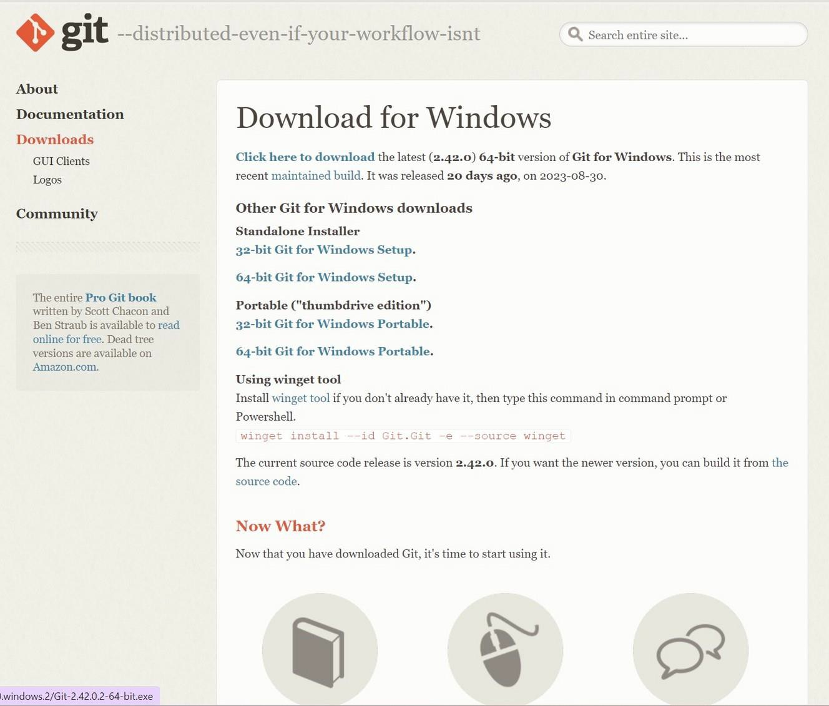

* 1. Clickonclickheretodownload.



* 1. Afterthedownloadiscomplete,openthedownloadedfile andthefollowingsetupdialogboxwillappear.

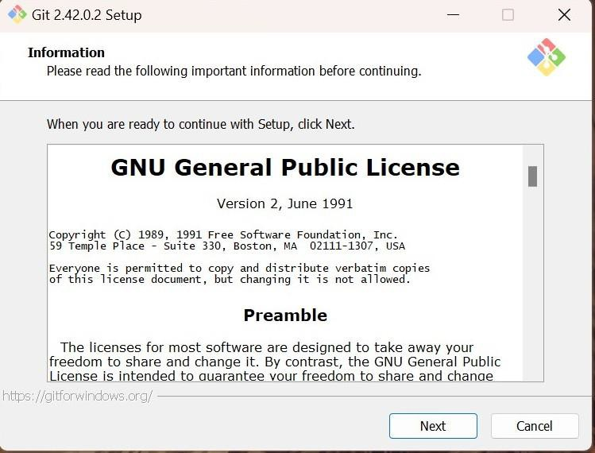

* 1. Keepclicking“next”untilthe followingdialog box appears. Now click ”install”and git would be installed.Clicking finish would launch Git Bash.

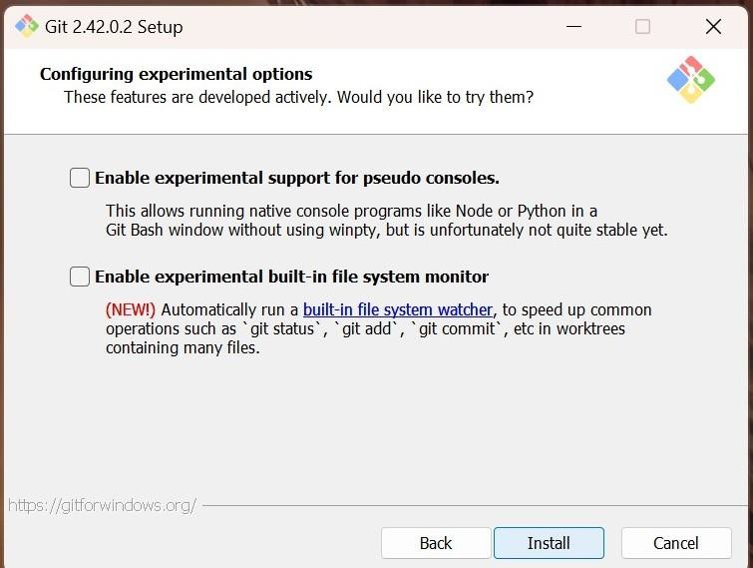

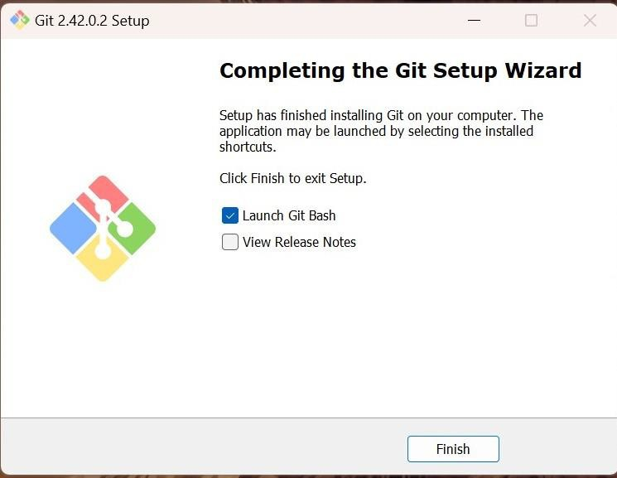



# WhatisGitBashandwhyareweusing?

Git Bash is a Windows application that emulates a Linux-like command line interface, enabling Git usage. Itinstalls Bash, common utilities, and Git, providing a familiar environment for Windows users to work with Git as it resembles Linux and macOS terminal experiences.



# ConfigureGit:

 git configcommand is used for configuringour username and email address. Sofor configuration, we can type the following command:

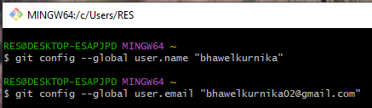



# ConfigureGit:

 gitconfig--listCommand.(Toverifyconfiguredusernameandemail)

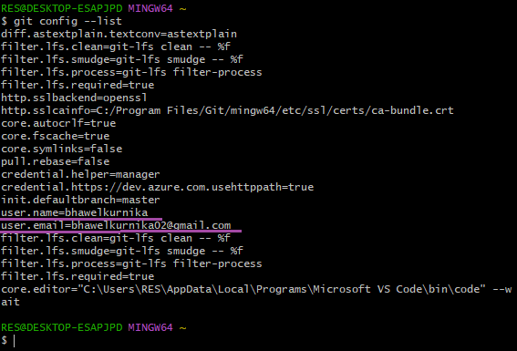

# BasicCommands:Clone

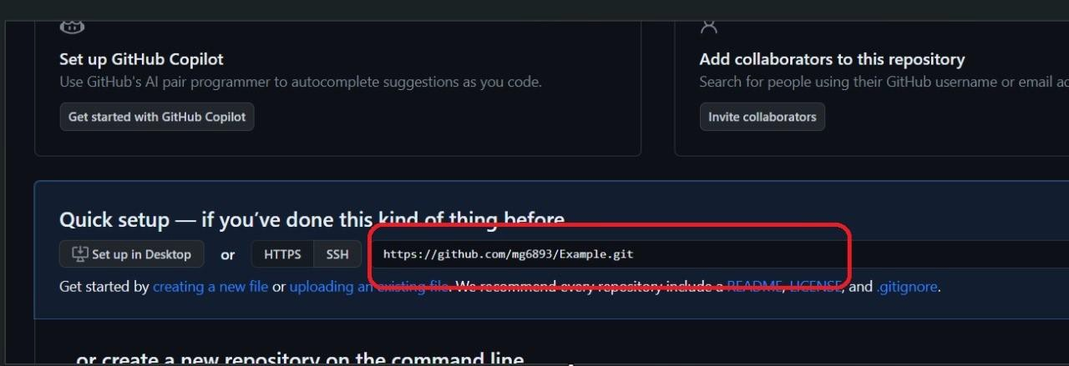

"Clone"inGitHubmeansmakingacopyof a repository from the remote server to your local computer for editing.

syntax:gitclone<link>



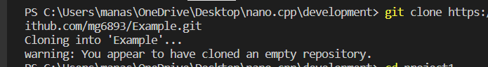

# GitStatus

“gitstatus”isaGitcommandthatdisplays the current state of your local Git repository, showing which files have been modified,added,ordeleted,andtheir statusinrelationto thelastcommit.It helps you track changes before committing them.

syntax:gitstatus



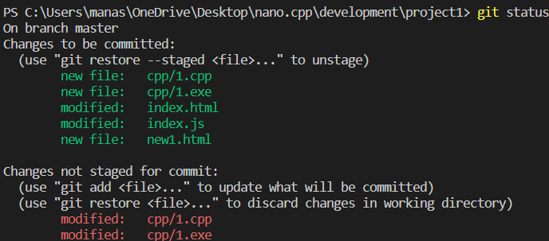

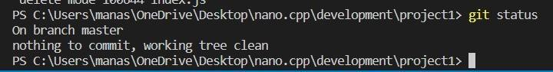

# Statusofafile/Repo:

“Untracked”:Newfilesthatgitdoesn'tyettrack. “Modified”:Changed/Changesmadeinfile. “Staged”:Filesreadytobecommitted. “Unmodified”:Unchanged.

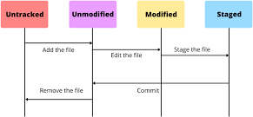

# HowGitTracks:

 add:Adds neworchangedfilesinour workingdirectory to git staging areas.

syntax:gitadd<filename>

gitadd.->toaddallthefilestostagingarea.

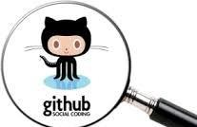 commit:Itrecordschanges afteraddcommands. syntax :gitcommit -m “message “





# Push:

 Usedtouploadrepocontenttoremote(ongithub).

 The"push"commandinGit,commonlyusedwithplatformslike GitHub,istheprocessofuploadingyour localcodechangestoa remote repository.Itsynchronizes your localcommits withthe remote repository, allowing collaboration and sharing of code changes with others workingon the same project.

 syntax:gitpushoriginmain.



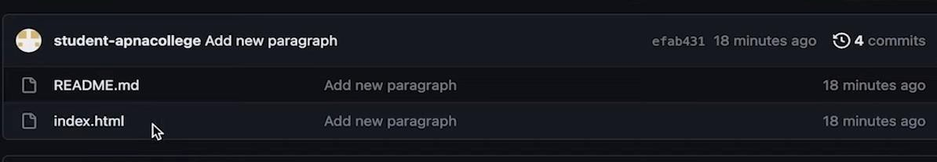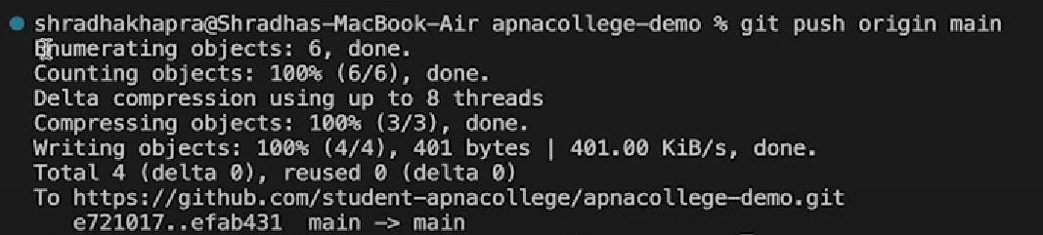



# Pullrequest:

 A "pullrequest"(PR)isafeatureonplatformslikeGitHub whereyou propose code changes to a repository. Others review,discuss,andpotentiallymergeyourchangesintothe main codebase. Itfacilitates collaboration and quality control.

syntax:gitpulloriginmain

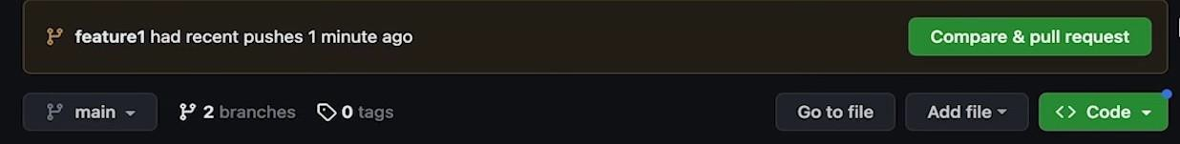

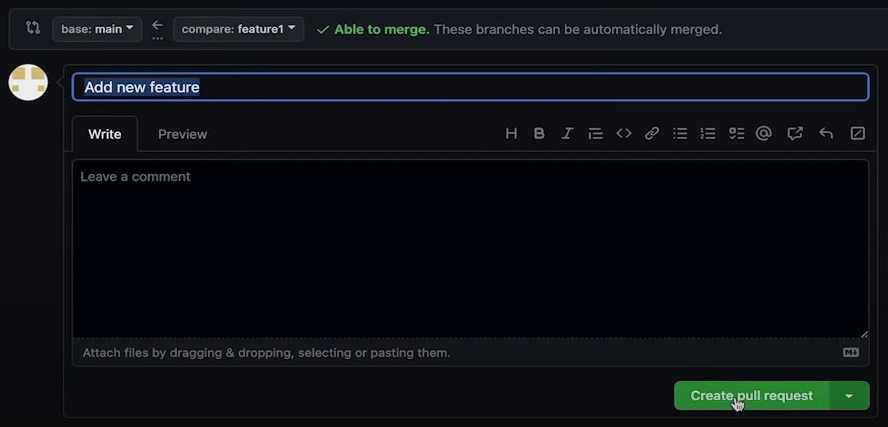



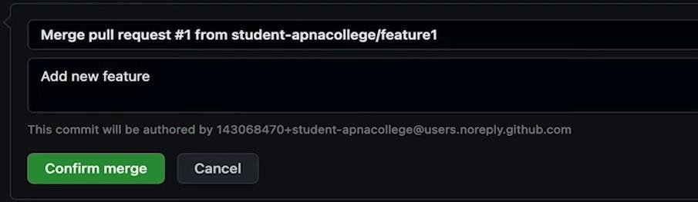

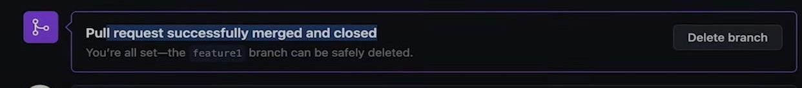

# Fork:

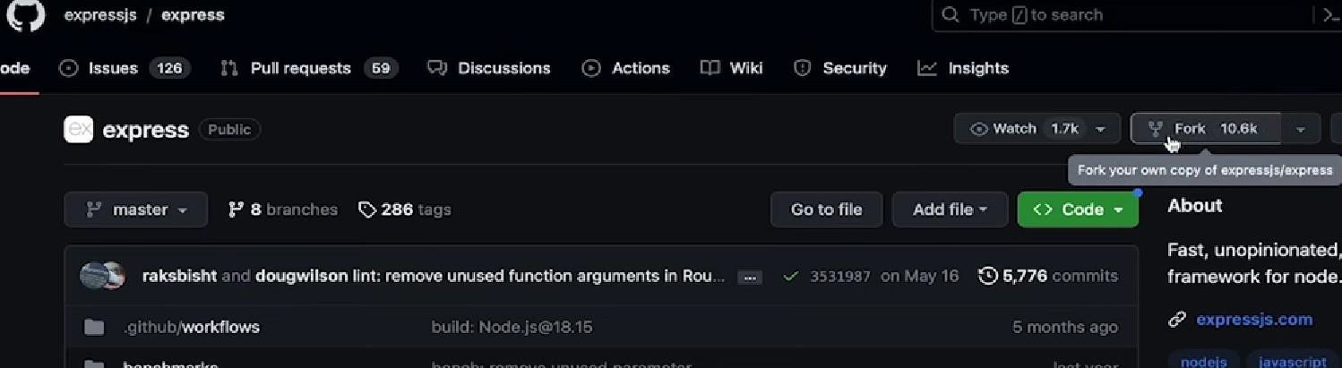

 The"fork"commandinGit,typicallyusedinplatformslike GitHub,createsapersonalcopyofarepository,allowingyou to make independent changes without affecting the original project.

 Forkislikearoughcopy



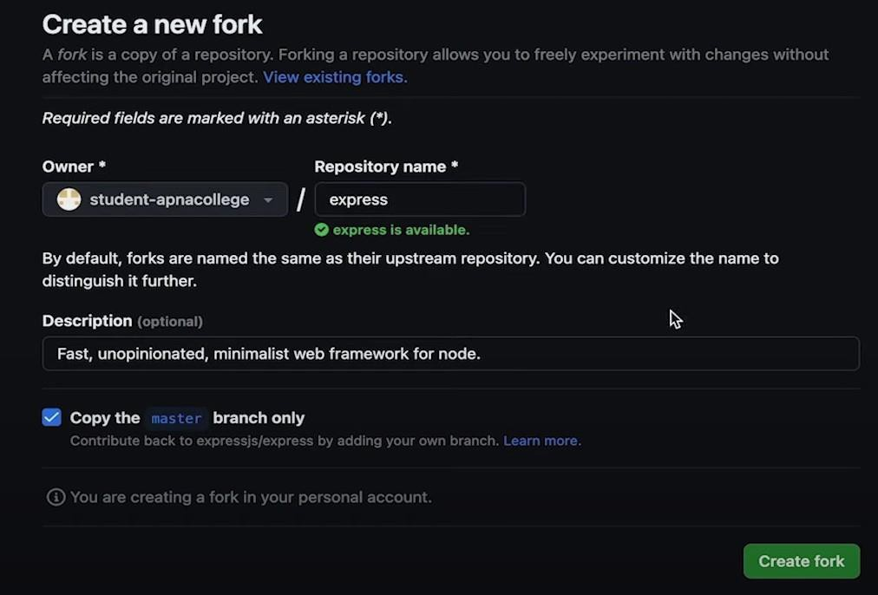

 

**THANKYOU!**

